Climate part II: The water cycle/ground water

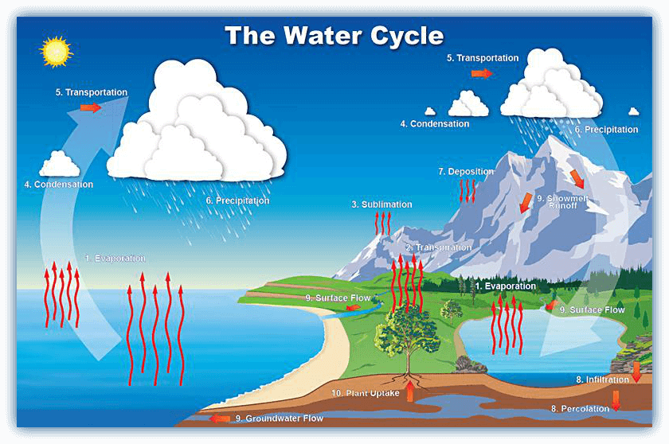
Name:__________________________________________ Date:___________________________
What happens to water when received at Earth’s surface?
1.) Water storage –
2.)Infiltration (seepage) –
3.)Runoff –
4.) Evapotranspiration –

Factors Which Effect Infiltration (the movement of ground water):
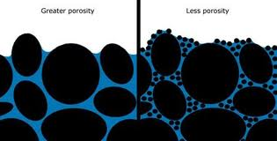
- Slope-
- Porosity-
The ________________ the porosity, _____________ infiltration will occur
Porosity is determined by the following:
- Shape –
- Packing-
- Sorting-If all particles are the same ___________ they are sorted.
- If the particles are different sizes/mixed they are ______________________
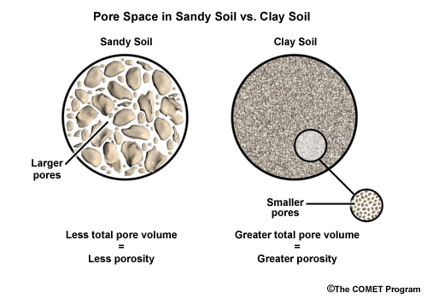
Relationship: _______________________________________________________
*_____________________ does _________________ effect porosity!
Ex: Sand has a _____________ porosity than clay even though it has a __________________________ grain size
- Degree of Saturation-

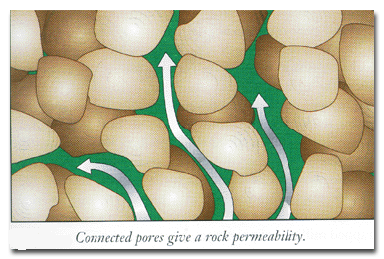
- Permeability-

Impermeable-

Relationship: The _________________ permeable the soil/rock, the ________________ the infiltration

- Retention-

___________________ with a ______________ in particle size.
Example: ______________sand has greater retention than ______________ sand

Main relationship: Smaller grains= _________________________________________

- Vegetation-

Main Relationship: little vegetation= ______________________________________________________
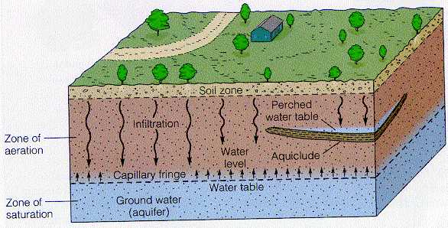
- Anthropogenic Influences (human construction)-

